**Issue Report of match founder on 08.10.2013**

1. Footer font style should look like as per PSD. See the screenshot:



1. <http://acumencs.com/founder/index.html> in this page there is a “t1”. See the screenshot:

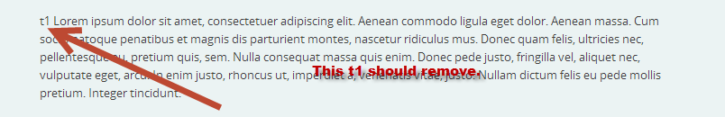

1. <http://acumencs.com/founder/index.html> in this page has a gap issue. See the screenshot:

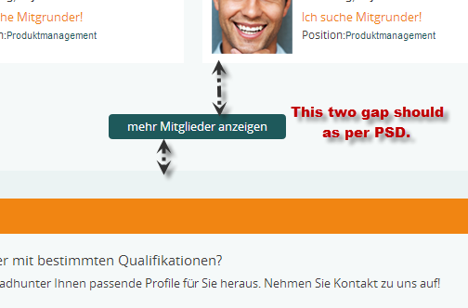



1. <http://acumencs.com/founder/index.html> in this page font style of content is not matching in Google chrome, IE 9, Safari browser.
2. <http://acumencs.com/founder/index.html> in this page there is a position issue (Google chrome, IE 9, Safari browser). See the screenshot:

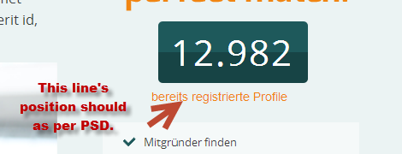

1. <http://acumencs.com/founder/index.html> in this page there is a font style issue.
2. There is a width issue (Google chrome, IE 9, Safari browser). See the screenshot:

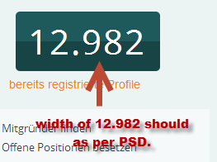

1. There is a gap issue. See the screenshot:



1. <http://acumencs.com/founder/region.html> in this page when user will mouse hover on the specific space then it will select the space by specific color as per PSD.
2. There is a position issue. See the screenshot:



1. <http://acumencs.com/founder/profile.html>

<http://acumencs.com/founder/region.html>

<http://acumencs.com/founder/positions.html>

in these pages there are a hover functionality issue. See the screenshot:

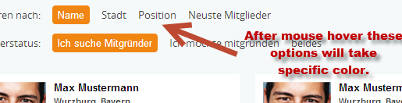

1. <http://acumencs.com/founder/positions.html> in this page there is a wrong heading. See the screenshot:



1. <http://acumencs.com/founder/positions.html> in this page there is a hover functionality issue. See the screenshot:

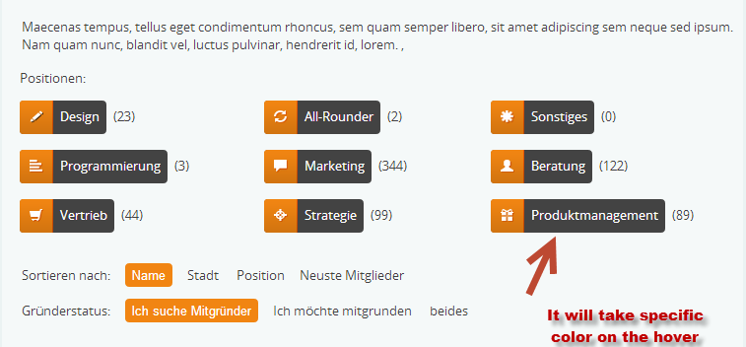

1. There are a footer content issue. (check it in all the pages) See the screenshot:



1. <http://acumencs.com/founder/search.html> in this page there is a content style issue. See the screenshot:



1. <http://acumencs.com/founder/register.html> in this page “Registern” word should in middle indent in the box as per PSD. See the screenshot:

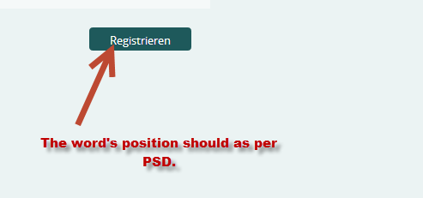

1. <http://acumencs.com/founder/content.html> in this page “t1” should remove. See the screenshot:

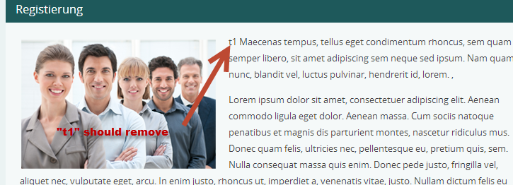

1. <http://acumencs.com/founder/content.html> in this page heading should as per PSD. See the screenshot:



1. <http://acumencs.com/founder/profile_user.html> in this page one font style is not matching with PSD. See the screenshot:

